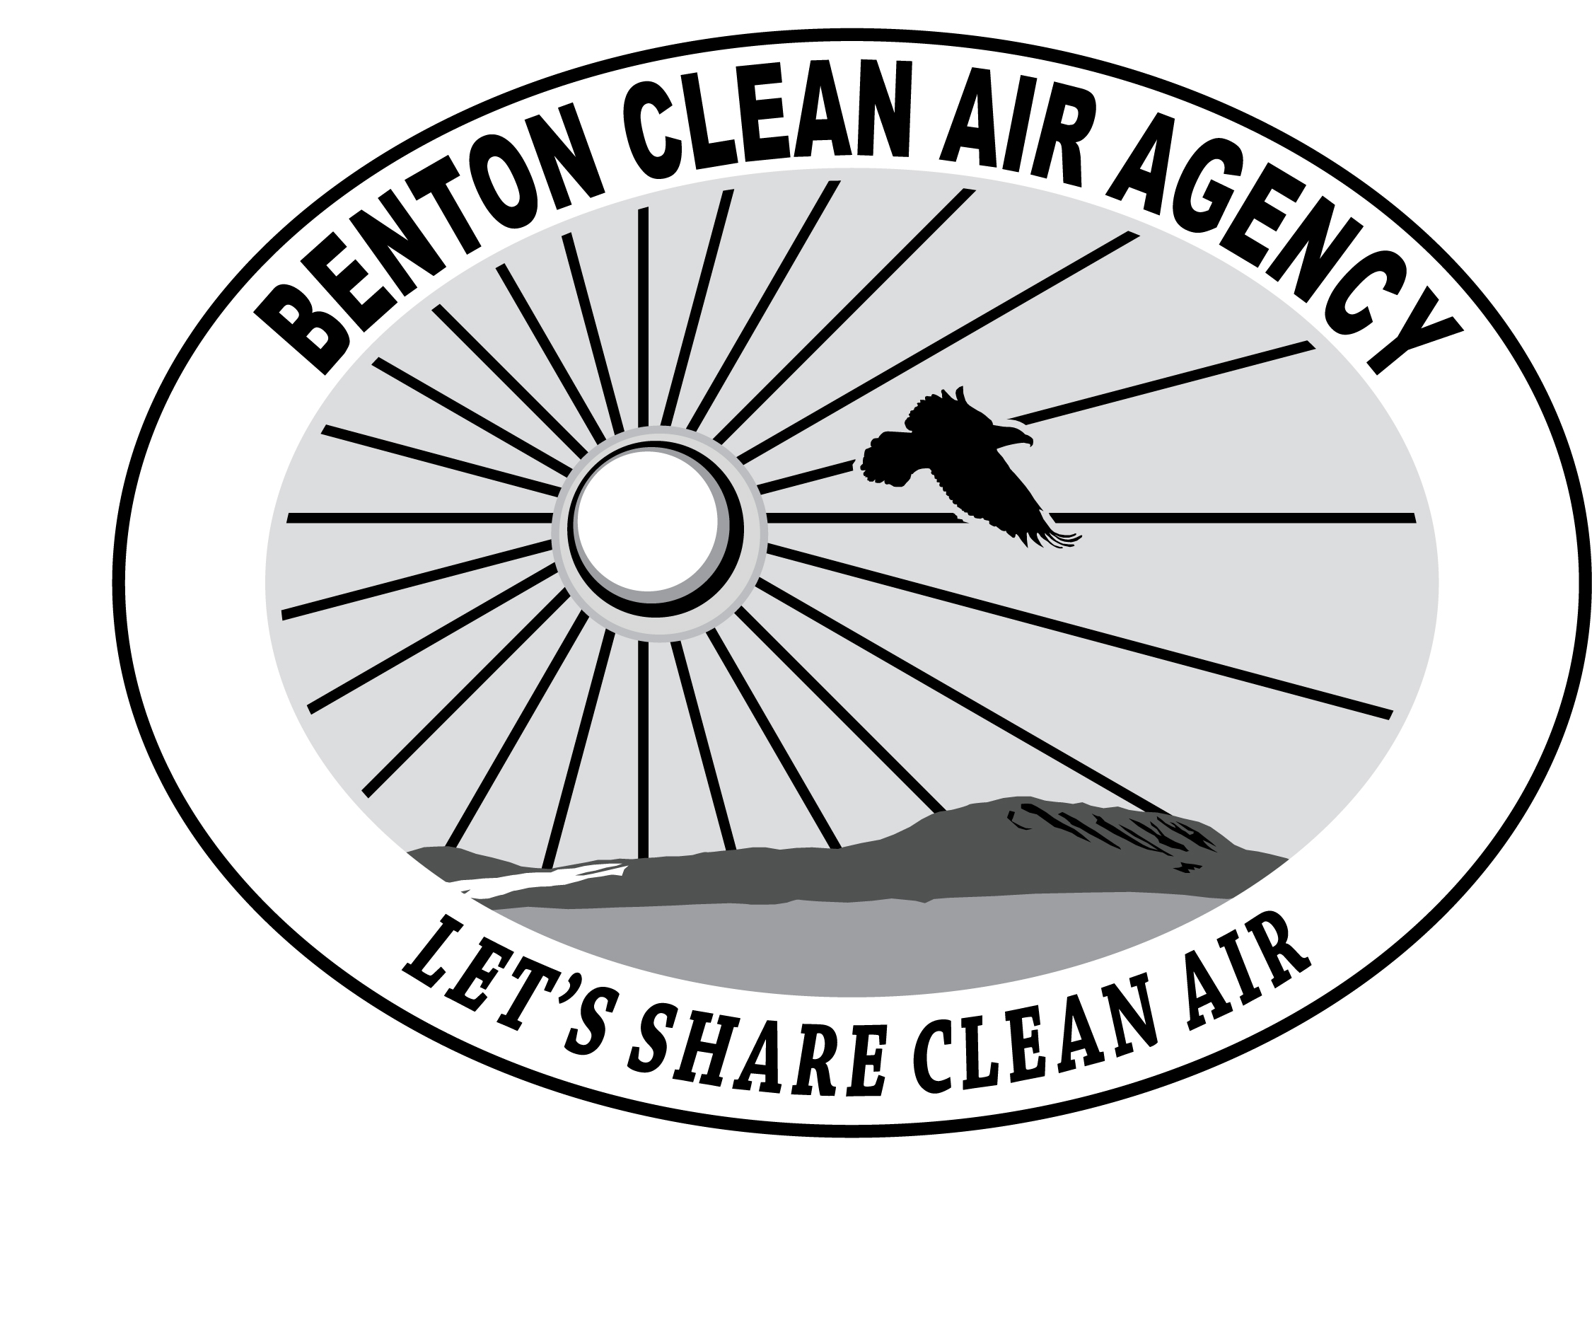 | BENTON  CLEAN AIR AGENCY

Change of Owner/Operator of a Registered Facility | For Agency Use Only

Facility
Old Name
New Name (if changed)
Facility Physical Address

Previous Owner/Operator
Name
Company Name
Phone Number

New Owner/Operator
Name
Company Name
Phone Number
Mailing Address

Billing Contact
Billing Address
Billing Phone Number

Technical Contact
Technical Address
Technical Phone Number

Date of Transfer

The new owner or operator must read the following and sign below.

I understand that as the new owner or operator of the above facility I am responsible for meeting all federal, state, and local air quality regulations, including all Notice of Construction approvals, New Source Review, source registration fees, and monitoring, reporting, and recordkeeping requirements.

Further, I understand that any liability for fee payment, including payment of delinquent fees and other penalties, shall survive any transfer.

Signature Date

Washington Administrative Code (WAC) 173-400-101(6) requires notification of change of ownership within ninety (90) days of change.

