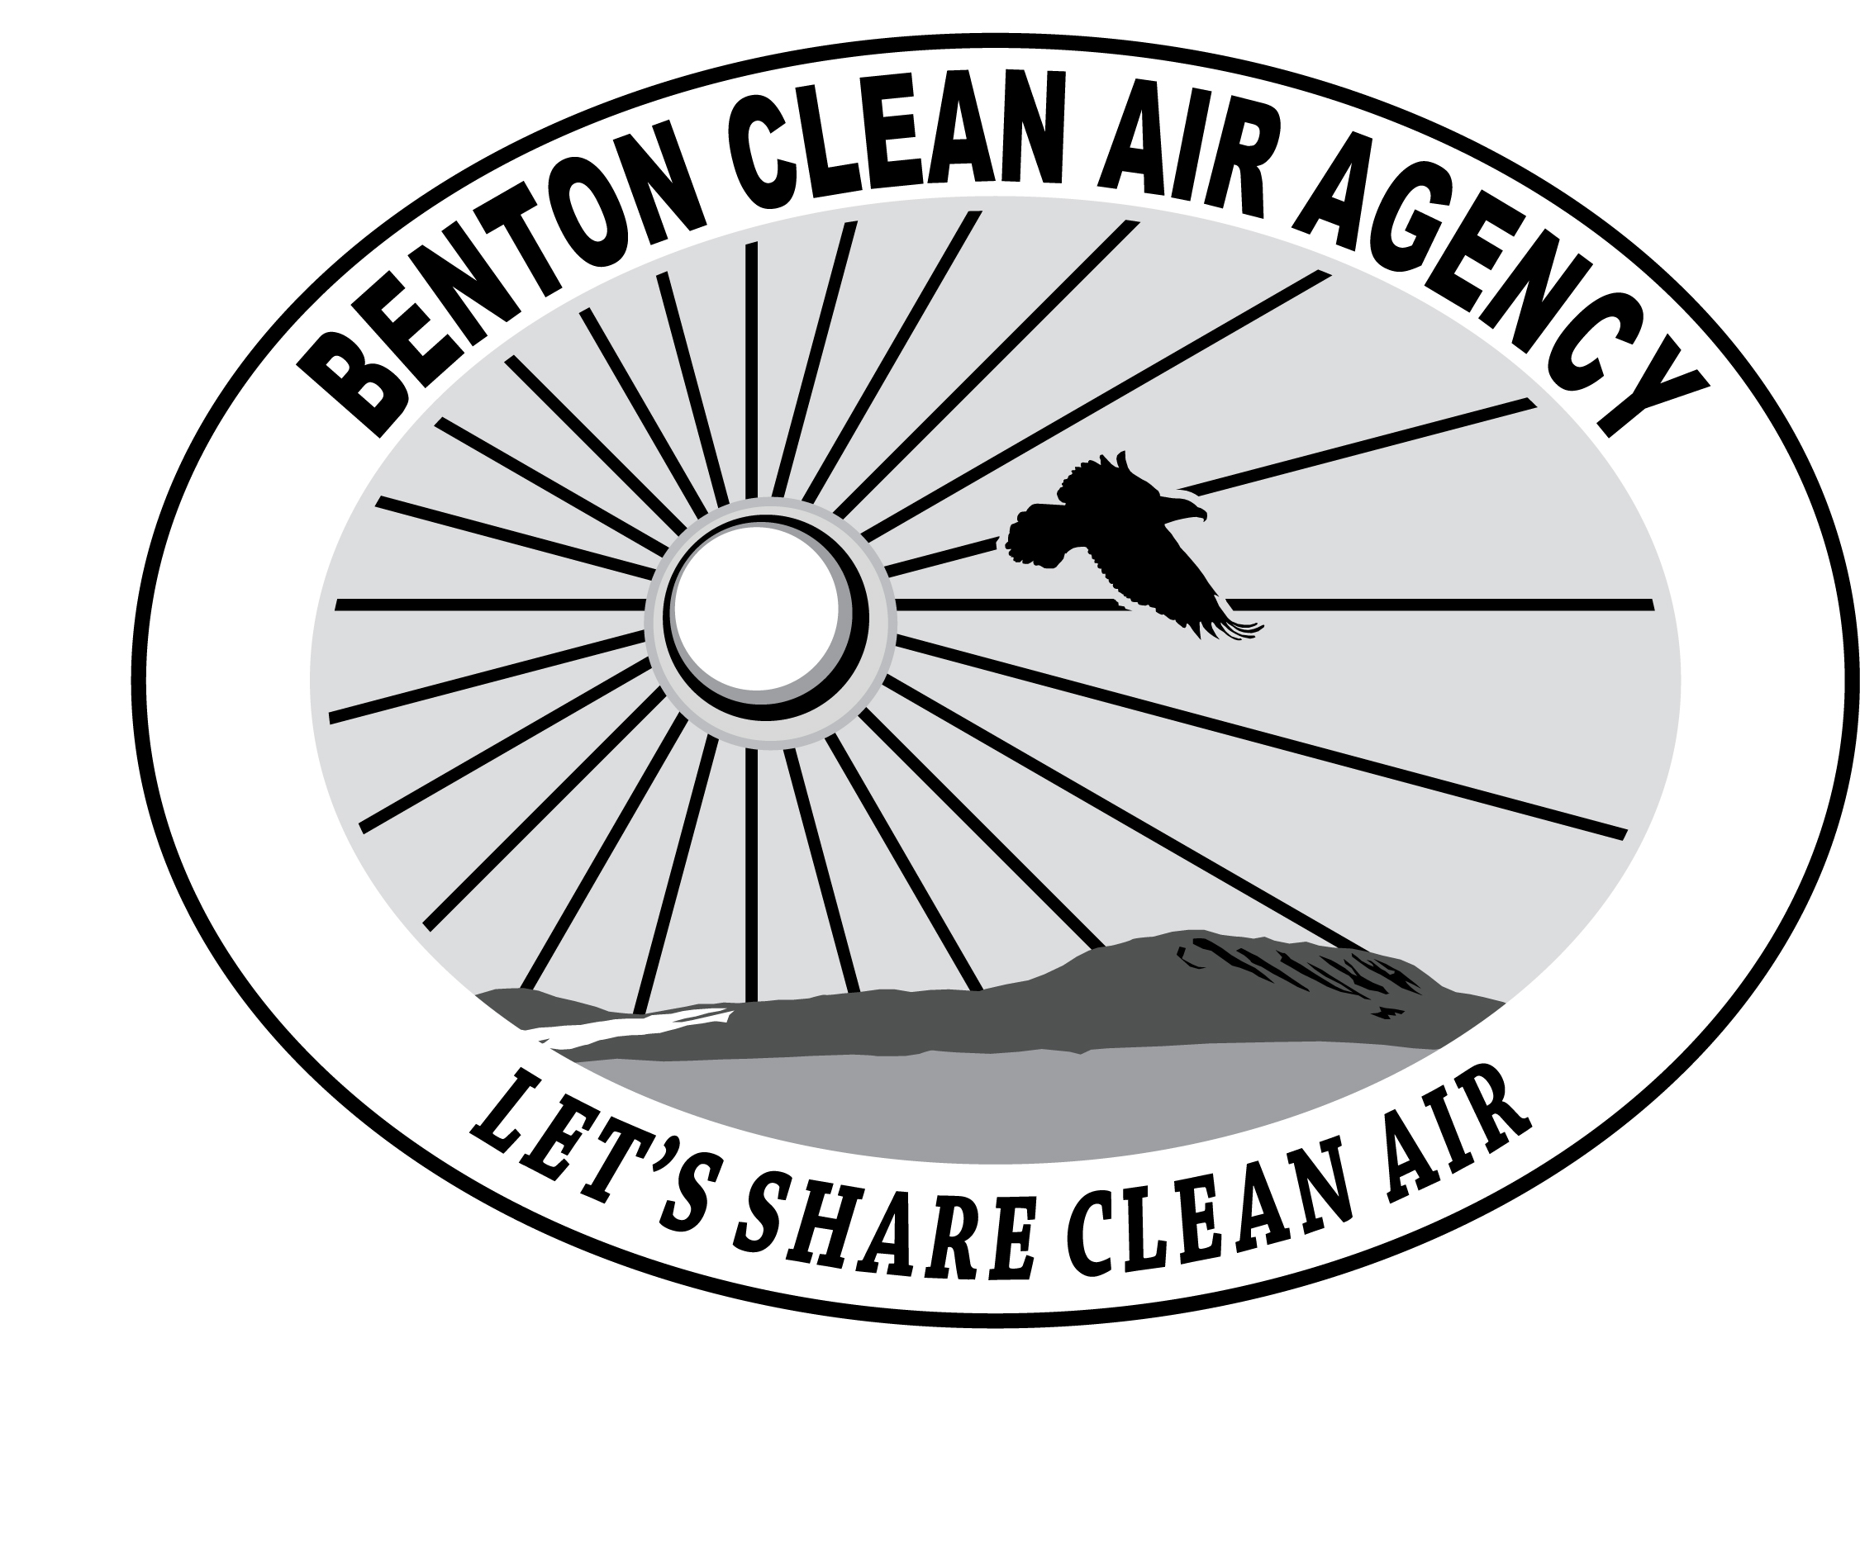 | BENTON  CLEAN AIR AGENCY

Report of Closure | For Agency Use Only

Company
Company Name
Owner Name
Site Address
Owner Phone Number

Date Source Ceased Operation

Owner, Operator, or Responsible Agent Signature
As the owner, operator, or responsible official for the above company, I understand that if operations that produce air emissions are reestablished at the above location or established at a new location, Benton Clean Air Authority must be contacted to determine whether a Notice of Construction is required.

Signature Date

Printed Name Phone Number

Washington Administrative Code (WAC) 173-400-101(5) requires notification of closure within ninety (90) days after operations permanently cease.

